Tenda MW5-How to set bridge mode?

Note: In brige mode, your nova can access the internet only after being connected to a router with internet connectivity.

In bridge mode, the guest network, parental control, port forwarding, UPnP, DNS, QoS and DHCP server functions become unavailable.

Step 1: Open Tenda APP, choose “Settings”> “Internet Settings”

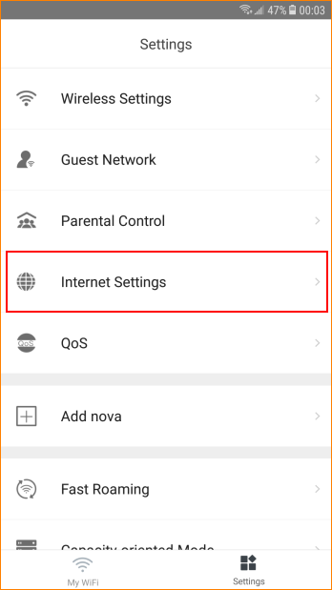

Step: After finishing settings, please tap “Save”

